**Wordpress**

**What to do before releasing the site to the client.**

check pages title, description, canonical

config.php -> debug mode false et setter les secret keys

**Theme Development Checklist**

<https://codex.wordpress.org/Theme_Development_Checklist>

Test Units: <https://codex.wordpress.org/Theme_Unit_Test> (dummy data)

**Install plugin: Theme Check**

Appearance -> Theme Check

- Missing css: copier celui d'un thème default, ex. twentyfifteen

- Text domain: <?php _e( 'Sorry, no pages found.' ); ?>

changer pour <?php _e( 'Sorry, no pages found.', 'name-of-theme-directory' ); ?> ex: teamtreehouse-portfolio

**Install plugin: All in One SEO Pack Michael Torbert? MiguéArpenteur.com**

**Yoast semble mieux par contre**

**Install plugin JetPack comme analytics? Mais surment plus lent que Google Analytics?!**

**Migrating Wordpress from Local to Live Server**

FTP all files to the server

Dans XAMPP, phpmyadmin, select the database, click Export:

Custom Export, select all, save output to a file. Go

Cpanel: create a new database using the wizard and a new user with all privileges

Cpanel, phpmyadmin, select the new database, import, choose file, Go

Edit wp-config.php, update the database, user infos, etc.

Dans wp-config.php, ajouter define WP_HOME et WP_SITEURL:

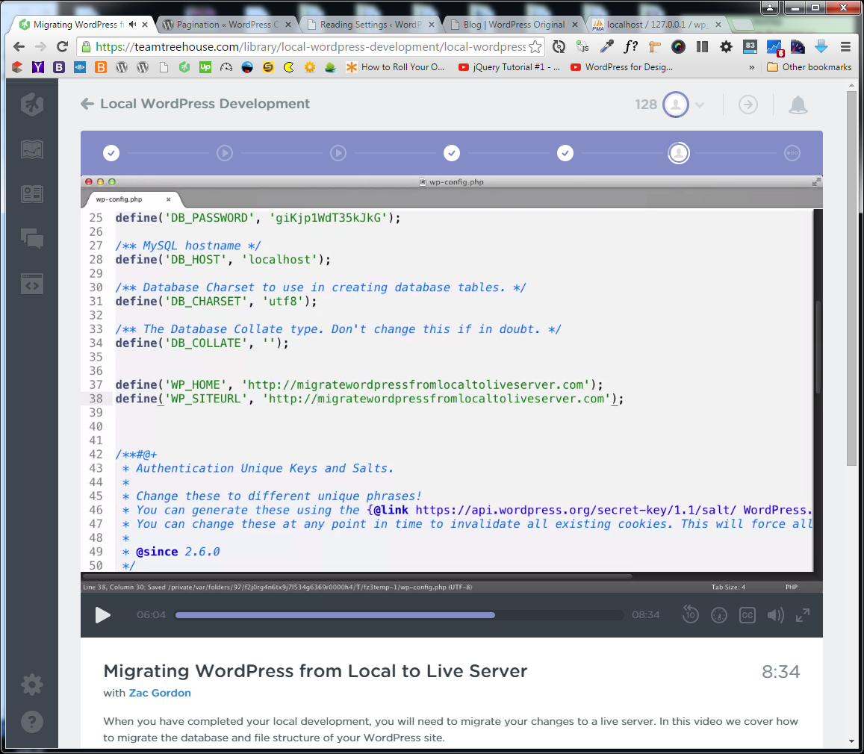

define('WP_HOME', 'http://www.solidwebmedia.com/wordpress-original-v2');

define('WP_SITEURL', 'http://www.solidwebmedia.com/wordpress-original-v2');

Changer:

define('WP_ENV', 'development');

define('WP_ENV', 'production');

Installer un Plugin: Search and Replace ex: Frank Bultge? Sinon Better Search Replace by Expanded Fronts et Matt Shaw

Tools > Search & Replace

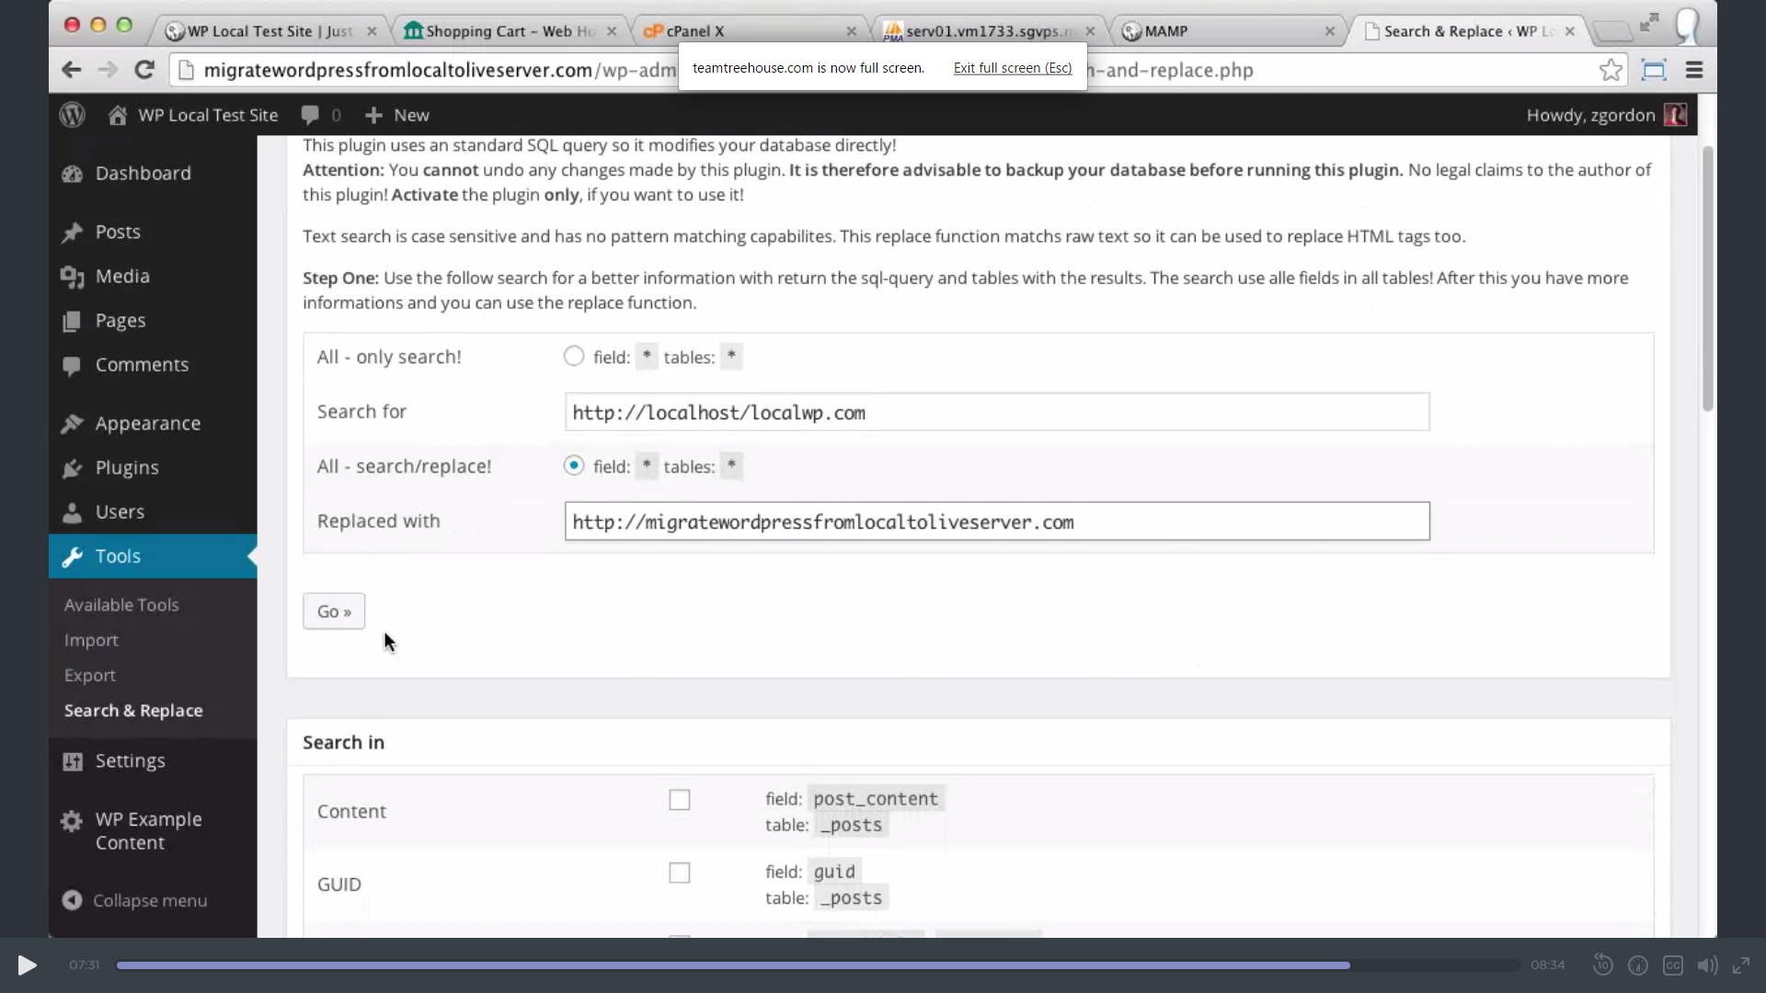

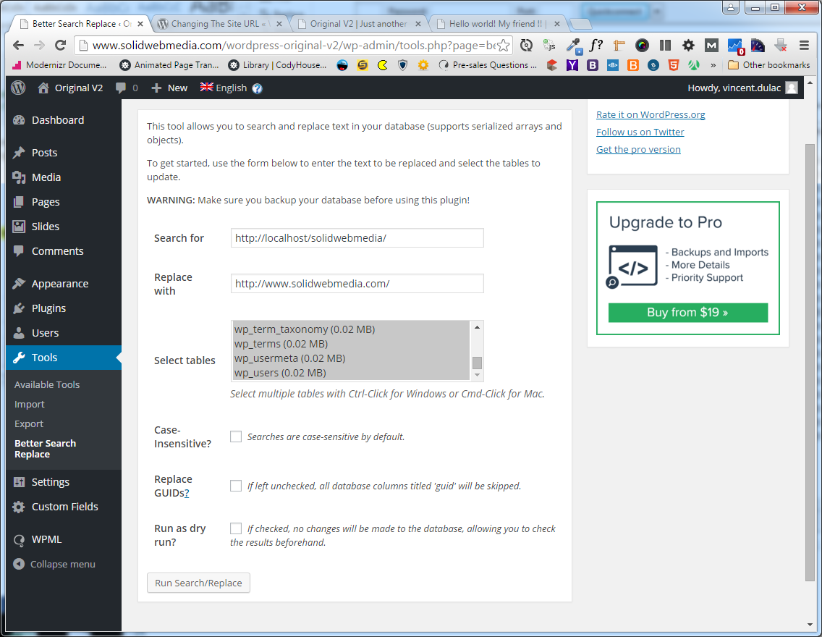

Result:

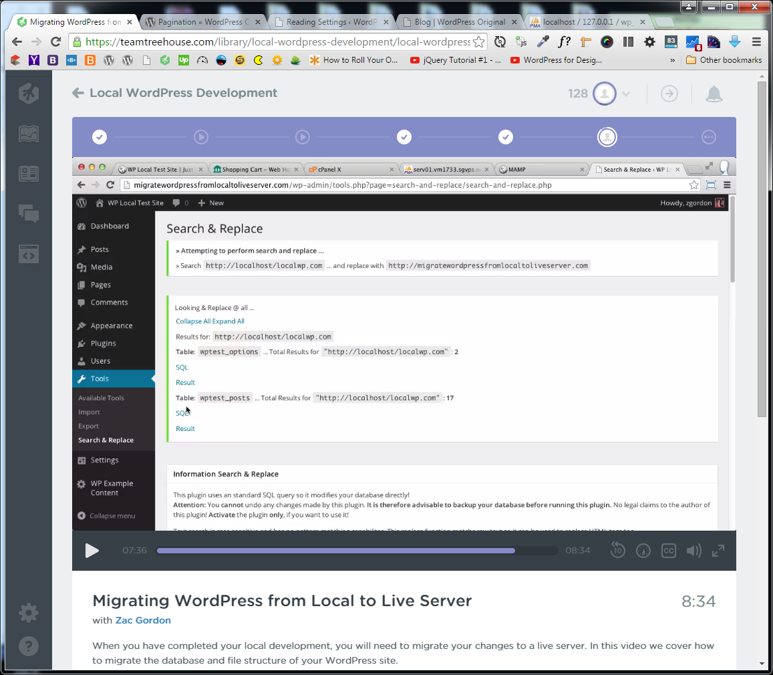

Il faut parfois aussi retourner dans Dashboard/Settings/Permalinks/Post name/ SAVE! Pcq htaccess est pas le meme locally et sur serveur.

Pour activer cache ds htaccess:

#RewriteCond %{QUERY_STRING} ^$

#RewriteRule ^$ wp-content/plugins/load-me-quickly/cache/index.html [L]

#RewriteCond %{QUERY_STRING} ^$

#RewriteRule ^gmaps/$ wp-content/plugins/load-me-quickly/cache/gmaps.html [L]

**Favicon:**

Ajouter le favicon.ico au root de wordpress?

**On a side note: import/export**

CTP UI > import/export Exemple: Portfolio in Admin Menu

Dashboard > Tools > Export > Import > WordPress